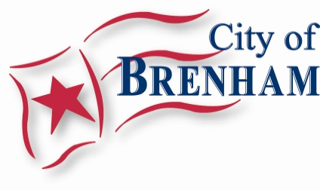

IMPORANT DATES TO REMEMBER

Written notice of proposed annexation to property owners, BISD, Washington County, EMS, Volunteer Fire Departments, sanitation companies that provide service to the area, and railroad companies with right-of-way in the proposed annexation area. | December 4, 2020
Publication of the Notice of Annexation. | December 22, 2020
Planning and Zoning Commission Public Hearing to discuss proposed zoning. | December 21, 2020
Brenham City Council Public Hearings on the annexation and proposed zoning.  First reading of the annexation and zoning ordinances. | January 7, 2021
Final reading of annexation and zoning ordinances. | January 21, 2021

